Chapter 14: Tell Me How...

Tujuh Pembelajaran:

Setelah mempelajari Bab 14, siswa diharapkan mampu:


1 Mensyukuri kesempatan dapat mempelajari bahasa Inggris sebagai bahasa pengantar komunikasi International yang diwujudkan dalam semangat belajar.

2.1Menunjukkan perilaku santun dan peduli dalam melaksanakan komunikasi interpersonal dengan guru dan teman.

2.2Menunjukkan perilaku jujur, disiplin, percaya diri, dan bertanggung jawab dalam melaksanakan komunikasi transaksional dengan guru dan teman.

2.3Menunjukkan perilaku tanggung jawab, peduli, kerjasama, dan cinta damai, dalam melaksanakan komunikasi fungsional.

_{3.9}Menganalisis fungsi sosial, struktur teks, dan unsur kebahasaan dari teks news item berbentuk berita sederhana dari koran/radio/TV, sesuai dengan konteks penggunaannya.

4.13Menangkap makna dalam teks berita sederhana dari koran/radio/TV.


- Kelas XII SMA/MA/SMK/MAK

A. WARMER: Board Race

Your teacher will divide the students into four groups. Each student in each group should in turn race to the board and write a noun or a verb related to cooking. The group that writes the biggest number of nouns/verbs is the winner. An example is provided for you.

Group 1 | Group 2 | Group 3 | Group 4
bake | banana | banana | mix
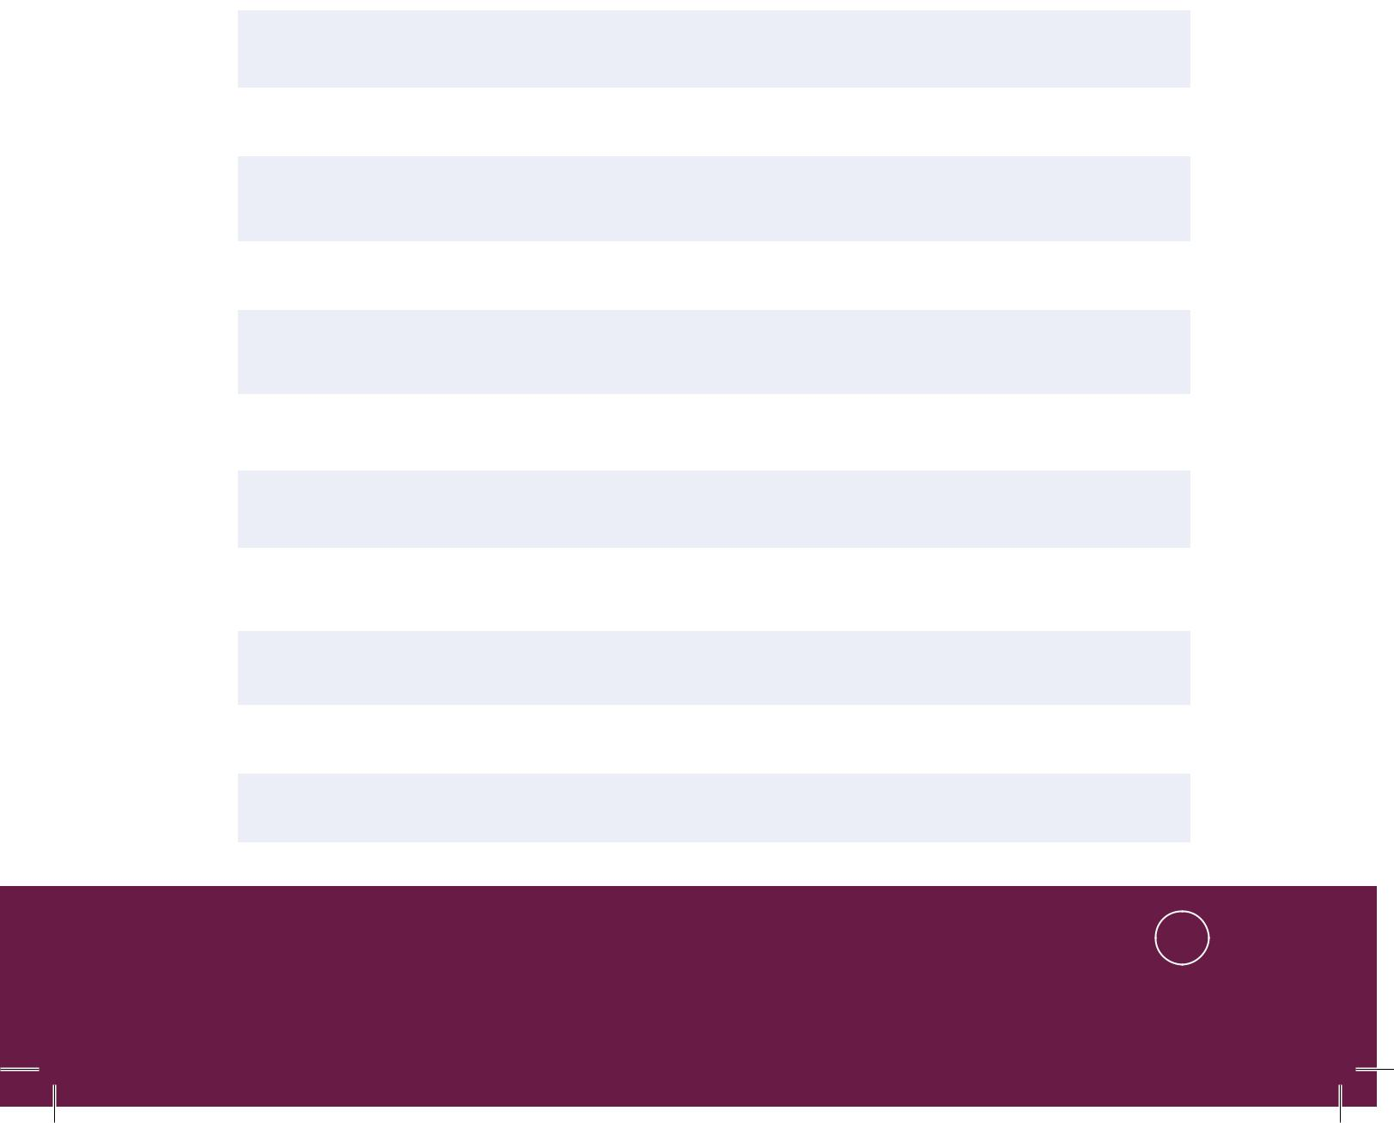

Bahasa Inggris | 207

B. OBSERVING AND QUESTIONING

Listening

Task 1: Now, close your book and listen to your teacher reading a recipe to make ‘Chocolate Dipped Strawberries.’ While listening, make a note on the keywords.
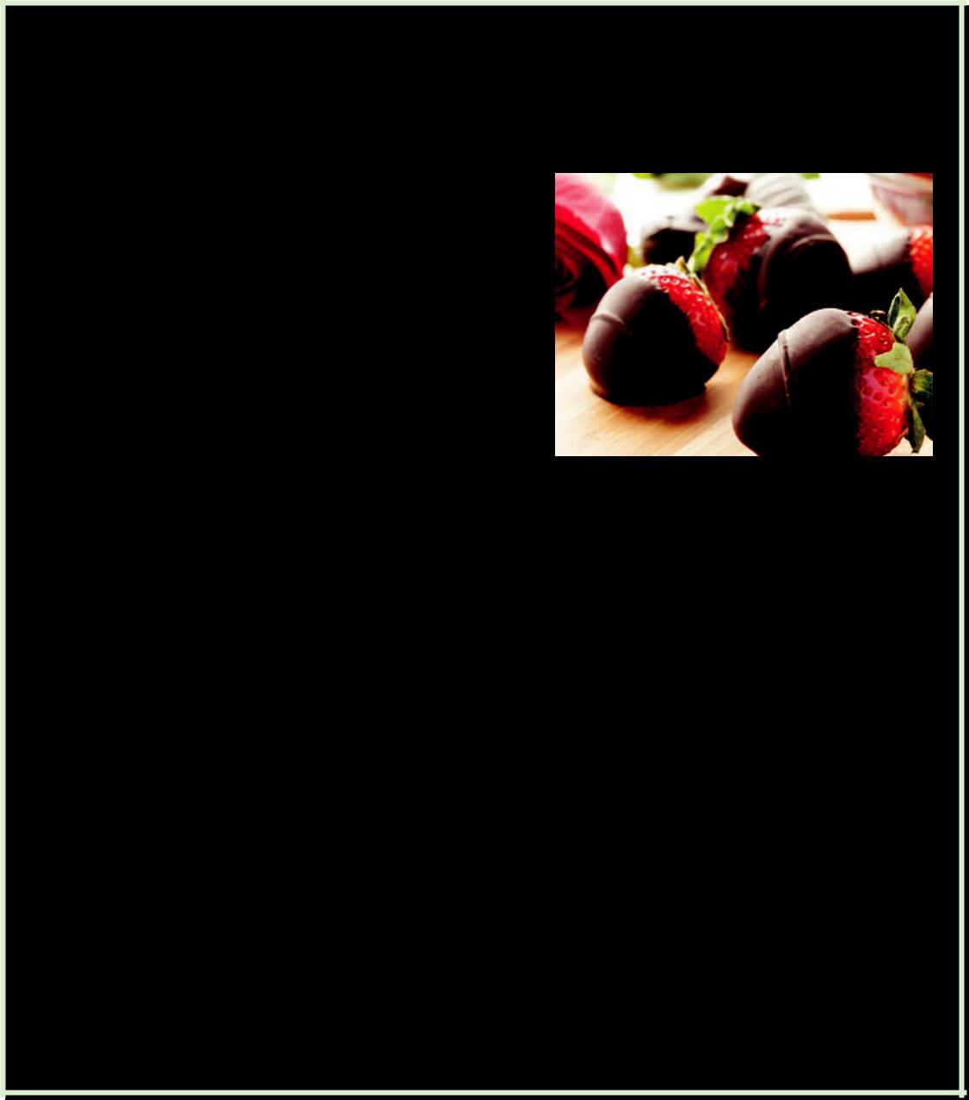

How to Make Chocolate Dipped Strawberries

To make chocolate dipped strawberries, first, prepare all the ingredients:

- 2 chopped squares semisweet or bittersweet chocolate
- ½ tablespoon whipping cream

- Dash almond extract.

- 8 strawberries

Source: http://www.daylightfoods.com Picture 14.1 chocolate covered strawberries

Second, combine the chocolate and the whipping cream in a glass measuring cup or bowl. Microwave at medium power for 1 minute until the chocolate melts, stirring after 30 seconds. Stir in the almond extract and cool slightly.

Finally, dip each strawberry into the melted chocolate, allowing the excess to drip off. Place on a waxed paper—lined baking sheet. Refrigerate or freeze for approximately 15 minutes until the chocolate is set.

- Kelas XII SMA/MA/SMK/MAK

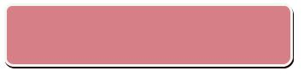

- Share your note with your friend next to you. Discuss any difficult words that you find.
- Listen again to your teacher reading the recipe and complete your note.

Vocabulary Builder

Task 2: Observe the recipe above, and write down the synonyms of the following words.
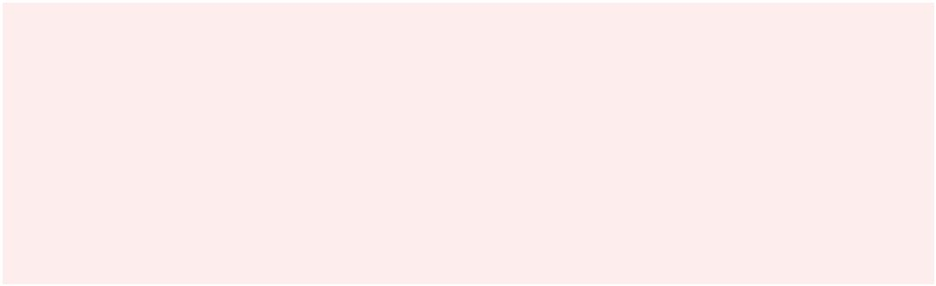

dipped | whipping cream
chocolate | stir, stirring
semisweet | melted
bittersweet | waxed paper
chopped | lined baking sheet

Pronunciation Practice

Task 3: Listen to your teacher reading these words. Repeat after him/her.

1 | . d i p ( v ) : /dɪp/
2 | . i n g r e d i e n t ( n ) : |  |  | /ɪnˈ gridiənt/
3 | . c h o p |  | ( v ) : /ʧɑp/
4 | . d a s h |  | ( n ) : /dæʃ/
5 | . c o m b i n e ( v ) : /ˈ kɑmbaɪn/
6 | . m e l t |  | ( v ) : /mɛlt/
7 | . s t i r ( v ) : /stɜr/
8 | . c o o l |  | ( v ) : /kul/
9 | . e x c e s s ( n ) : /ˈ ɛkˌ sɛs/
1 | 0 . | d r i p o f f ( v ) : |  | /drɪp ɔf/
1 | 1 . | s e t | ( a d j ) : /sɛt/


Bahasa Inggris | 209

Task 4: Follow the instructions.

Again, listen to your teachers’ instructions to make Chocolate Dipped Strawberries. Follow the instruction by doing some actions as if you really make the Chocolate Dipped Strawberries.

Text Structure

Task 5: Observe the text structure.

The text about chocolate dipped strawberries above is called a procedure. A procedure text aims at describing how something is done or made through a sequence of actions or steps.
How are procedures written? In the model text, the title shows the goal, that is, the name of the procedure to be carried out (i.e., How to make chocolate dipped strawberries). This is then followed with a list of materials, that is, a list of things which are needed in making the chocolate dipped strawberries. The next part refers to the procedure, that is, the steps to be followed in making the chocolate dipped strawberries.
A procedure text contains a lot of commands (imperative sentences) such as Combine, Dip, etc. and time sequencers such as first, second, etc.
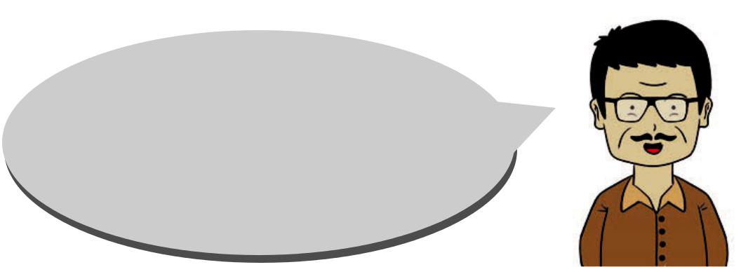

Still related to the recipe above, play the roles of the speakers in the dialogs. Complete the blanks with suitable expressions.

- Kelas XII SMA/MA/SMK/MAK

- Which one do you like, the semisweet or the bittersweet one?

- I like the bittersweet one.

- __________________________ chocolate dipped strawberries?

- Sure, first prepare the ingredients.

- ___________________________?

- 2 squares semisweet or bittersweet chocolate,

  - tablespoon whipping cream, dash almond extract and 8 strawberries.

- What’s the next step?

- Mix chocolate ______________________________

Then _____________________________________

- Why should it be cooled slightly?

- __________________________________________

- _________________________________________?

- Dip each strawberry into the melted chocolate.

- _________________________________________?

- About 15 minutes.

- Do you know what text structure is used in the text about how to make chocolate dipped strawberries above?

- It’s a sequential text structure.

- _________________________________________?

- The author puts steps in making the chocolate dipped strawberries.
- What’s ___________________________________?

- The author would like to inform the readers about the way to make chocolate dipped strawberries.

Bahasa Inggris | 211

C. COLLECTING INFORMATION


Now, bring a recipe from home. Read the recipe that you have brought from home, and fill in the blanks below.


TITLE:

Ingredients:

The 1st step:

The 2nd step:

The 3rd step:

The 4th step:

The 5th step:

The last step:

- Kelas XII SMA/MA/SMK/MAK

D. ASSOCIATING

Speaking


Now work in pairs and do the following instructions!

Task 1: Telling what steps to take

- Give your recipe to your friend.

- By referring to the note that you’ve just made, tell your friend about the steps he/she needs to do to make the food mentioned in your recipe.
- Ask your friend to check whether the steps you mention are the same with those in the recipe.
- Ask your friend to give you feedback.

- Exchange roles: your friend will tell you his/her recipe and you listen to him/her and do the above steps.

Task 2: Discussion

Discuss with your friend the similarities and differences between your recipe and his/her recipe.

E. COMMUNICATING

Task 1: Cloze Description
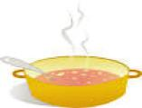

Fill in the blanks with the appropriate words.

Crab soup might become one of the favorite foods for many families. These are the steps
to make crab soup. | Source: www.123trf.com
 | Bahasa Inggris | 213

- Place whole tomatoes, water, lima beans, corn,

____________ carrots, chopped onion, Old Bay seasoning, and beef broth, in a 4 quart ___________. Heat to simmer, cover, and ____________________
for 5 minutes.

- Bring water to ____________. Add crab claws and boil 6 minutes. Drain ____________ and set aside
- Stir crabmeat (and crabs claws, if desired) into tomato and vegetable ____________. Cover and simmer 10-15 minutes longer. ____________ hot.

Task 2: Practice giving instructions.



In groups, practice giving and following instructions.

In turn, give instructions to your friends to make foods/cakes

in your recipe and ask your friend to do the actions.

Task 3: Discussion


Discuss with your friends in your groups of four the difficulties you feel in giving instructions and in following instructions and how to overcome them. To help you, you can complete the following table before and during the discussion.

- Kelas XII SMA/MA/SMK/MAK


Name | Difficulties
You | In giving instructions | In following nstructions
Your friend
Your friend
Your friend

R E F L E C T I O N

Do you know how to create a procedure? Respond to these questions to check whether you understand how to create a procedure text.

- Do you have the goal to accomplish?

- Do you have the materials/things/ingredients?

- Do you know the steps?

- Do you use commands?

- Do you use time sequencers?

- Do you pay attention to spelling, punctuation, capitalization, and formatting?
- Do you use references?

Bahasa Inggris | 215

